Design Concept:

1. One finding from the observation that inspired this design concept is our finding from 2.4, which is participants love features that will make drawing easier such as shaping and coloring tools. Especially tools with algorithm that can adjust the shape and color to make the whole drawing looks better.

2. The specific goal of our program is to help those people who are not very good at drawing and familiar with digital tools. When user want to draw something, we want to provide tools that will help user perfect their painting such as help user sketch the outline or shade.

Low-Fidelity Sketches：

Dingwen:

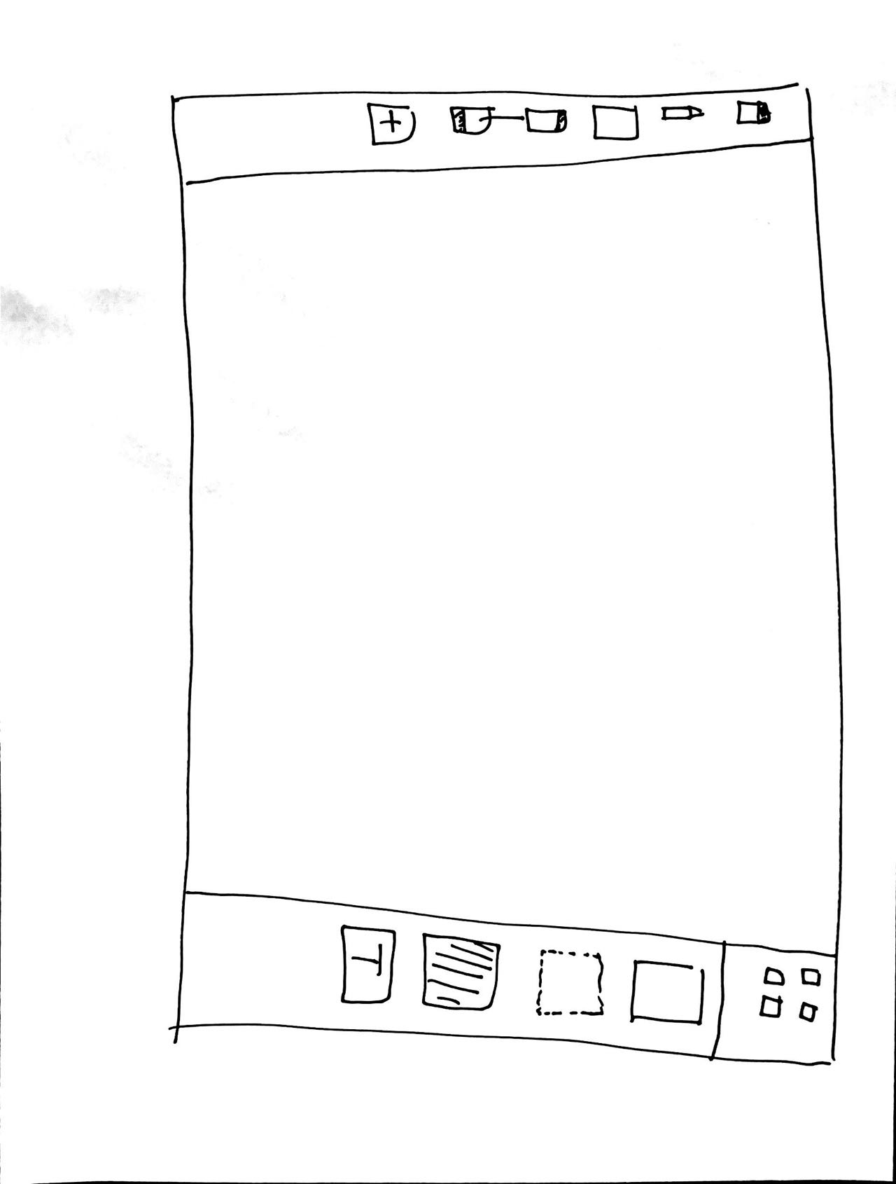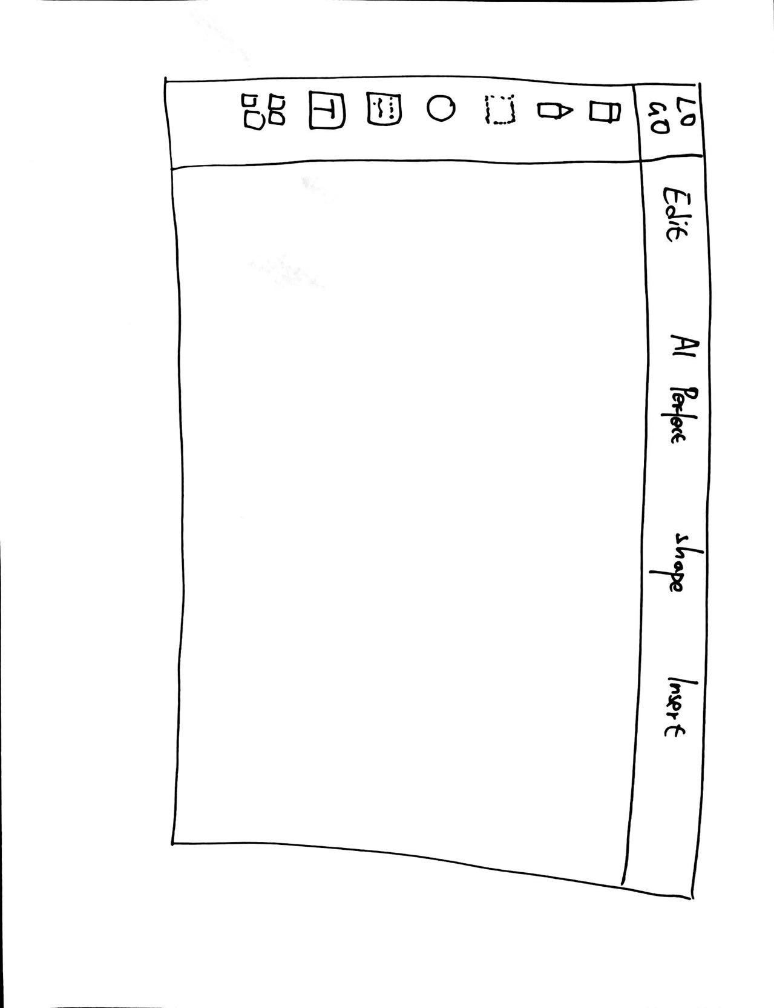\

Ziqian

Synthesis: consolidate your ideas: We both have large blank canvas for user to draw since we want to give user more freedom and space to paint. The effective part is the tool bar which has many kind of tools for user to use. And those symbols are not abstract. We might improve details such as the tools that will help user paint better.